

**IT7x30**

**Special topic diary**

**Semester 2, 2018**

**School of Information Technology**

Title Page

1. Recap modelling and animation blender 3

1.1 COMMON MOUSE ACTIONS IN BLENDER 4

2. Intro to Unity interactive environment 9

3. Scoping 9

4. Testing 9

5. Industry roles 9

6. Principles of storyboarding 9

7. Using reference material 9

8. Character design process 9

9. Game Docs 9

10. Planning 9

11. Media and animation theory 9

12. Some advances modelling tools 9

# Recap modelling and animation blender

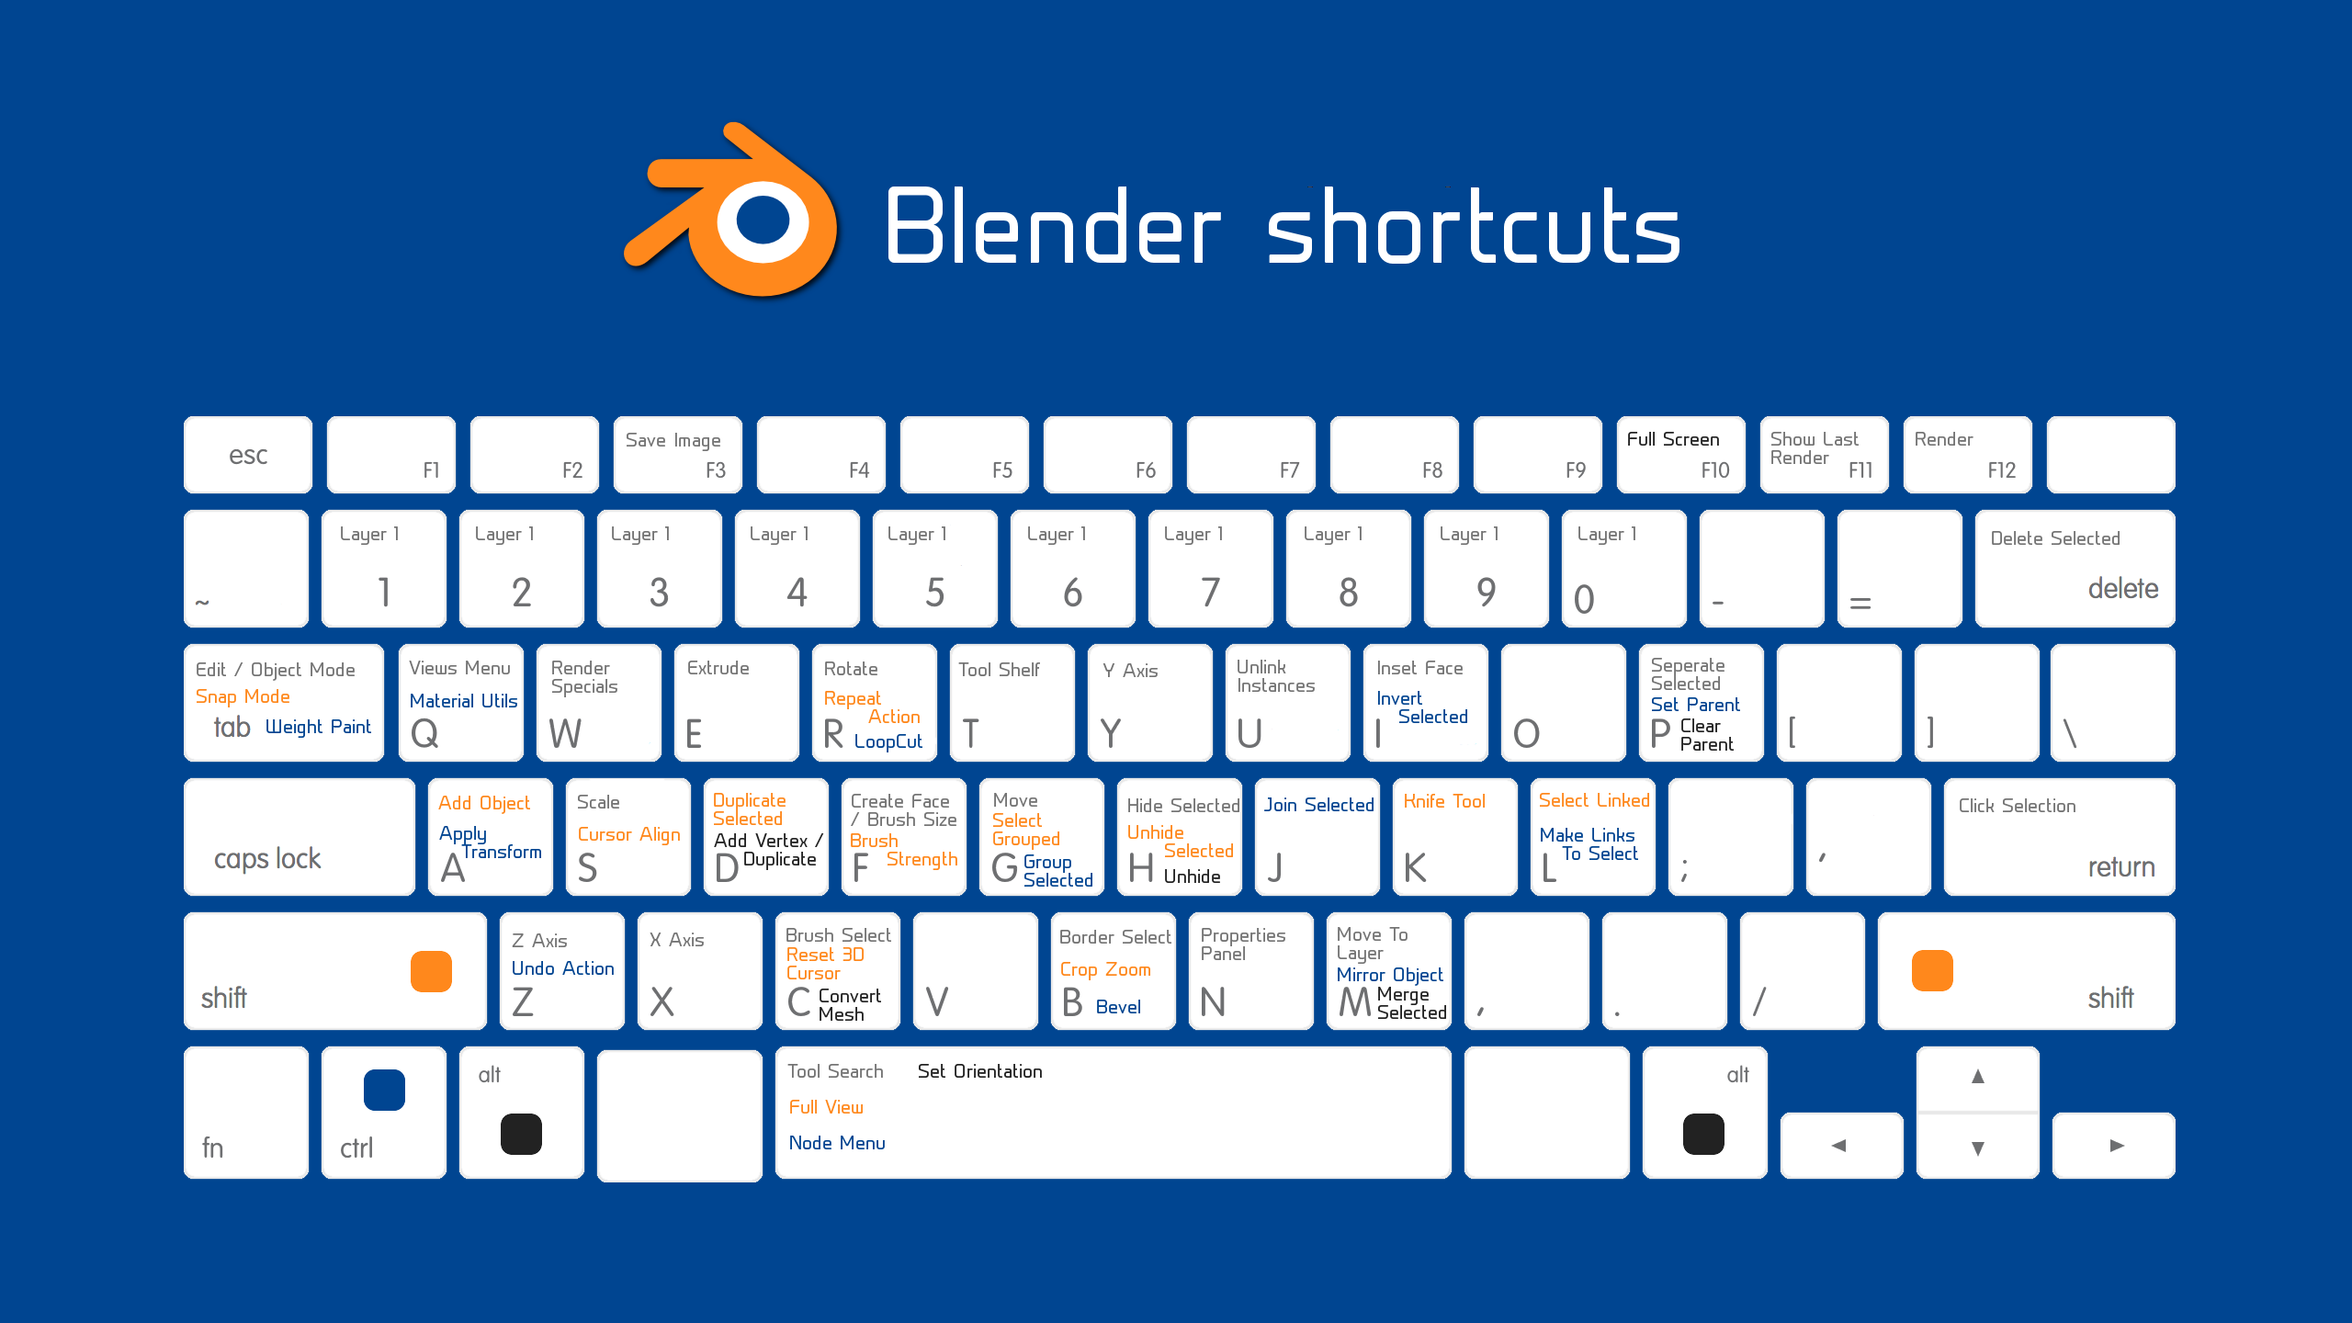

## COMMON MOUSE ACTIONS IN BLENDER

Blender makes it a point to use as many buttons on your mouse as possible. You have five fingers; you may as well get full use of them. This table gives you some of the most commonly used mouse behaviors.

Action Result

Left-click Place 3D cursor

Ctrl+left-click (edit mode) Quick-extrude

Ctrl+left-click+drag Lasso selection

Right-click Select

Shift+right-click Add to selection

Alt+right-click (edit mode) Edge/Face loop select

Middle-click+drag Rotate view

Shift+middle-click+drag Pan view

Ctrl+middle-click+drag Zoom view

## COMMON NUMERIC KEYPAD HOTKEYS IN BLENDER

The numeric keypad gives you a high-speed means of navigating the 3D View in Blender. The following table explains some of the more useful and common hotkeys that involve the numeric keypad. (Note: If you’re using a laptop that doesn’t have a numeric keypad, you can enable the Emulate Numpad check box in the Input section of User Preferences and use the numbers along the top of your keyboard instead of the numeric keypad.)

Hotkey Description

1 Front view

Ctrl+1 Back view

2 Rotate view up

Ctrl+2 Pan view up

3 Left side view

Ctrl+3 Right side view

4 Rotate view left

Ctrl+4 Pan view left

5 Toggle perspective/orthographic view

6 Rotate view right

Ctrl+6 Pan view right

7 Top view

Ctrl+7 Bottom view

8 Rotate view down

Ctrl+8 Pan view down

9 Redraw screen

0 Camera view

Ctrl+Alt+0 Set camera to viewport

/ Toggle local view

. (dot/period) Zoom on selection

+ Zoom into view

## COMMON KEYBOARD HOTKEYS IN BLENDER’S 3D VIEW

Blender is designed to be used with one hand on the keyboard and the other on the mouse. Nearly every key on a standard keyboard is assigned to some task within Blender, and sometimes more than one task. For example, the numbers across the top of the keyboard reveal each of the first ten Blender layers. Alt+Any number shows each of the last ten layers. Shift+Any number allows you to show more multiple layers simultaneously. And that’s not all! The following table shows some of the more commonly used hotkeys while working in Blender.

Hotkey Description

A Toggle select all/none

Alt+A Play animation in view

Shift+A Show Add menu

C Circle (Brush) select

Shift+D Duplicate

Alt+D Linked duplicate

E (edit mode) Extrude

F (edit mode) Create face/edge

G Grab/move

Alt+G Clear location

H Hide selected

Alt+H Reveal al

I Insert keyframe

Ctrl+J Join selected objects

L (edit mode) Select linked vertices

Shift+L (edit mode) Deselect linked vertices

M Move selection to layer

Ctrl+M Mirror selection

N Show Properties region

Ctrl+N New Blender session

Ctrl+N (edit mode) Calculate normals outside

O (edit mode) Enable proportional editing

P (edit mode) Separate to new object

Ctrl+P Make parent

Alt+P Clear parent

R Rotate

Alt+R Clear rotation

S Scale

Alt+S Clear scale

U (edit mode) Unwrap mesh

V Toggle Vertex Paint mode

W (edit mode) Specials menu

Ctrl+S Save file

X Delete selection

Ctrl+Z Undo

Ctrl+Shift+Z Redo

Spacebar Show search menu

Shift+Spacebar Maximize editor area

Ctrl+Spacebar Toggle manipulator

Alt+Spacebar Change manipulator orientation

Tab Toggle Edit mode

Shift+Tab Toggle snapping

# Intro to Unity interactive environment

Installing Unity

Your first task, if you have not already done so, is to download and install Unity. You should also set up a Unity account. Unity now has four license types: Personal, Plus, Pro, and Enterprise. Unity Personal is free, provided your company doesn’t earn more than $100K a year. For the most part, the remaining offerings provide you with services that will help you refine your games for better monetization and player experience.

Creating a Unity User Account

If you don’t already have one, you will be encouraged to create a Unity user account during the installation process. Your user account will provide access to the downloads, Unity Forums, Unity Answers, and the Unity Asset Store. The forums provide a place for discussion of all things Unity. Unity Answers is where you can go to get quick solutions to your queries, and the Unity Asset Store is where you can find assets of all kinds (3D models, animated characters, textures, scripts, complete game environments, and more) to help you with your project. After Unity is installed, you will find a direct link to each of these resources through the editor’s Help menu.

To get started, go to <https://store.unity.com> or follow the Get Unity links from the Unity3D home page. Currently, you will be given the following license options (Figure 1) as well as a comparison of the differences. Select the Personal edition.

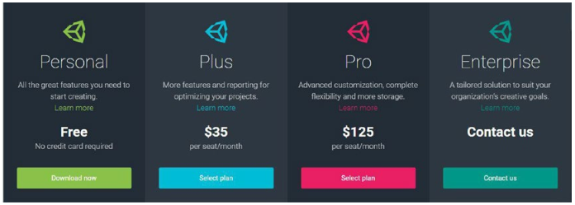

Figure 1

You will be taken to the next page, where the Personal edition’s system and eligibility requirements are stated; click the Download Installer button to download the installer (Figure 2).

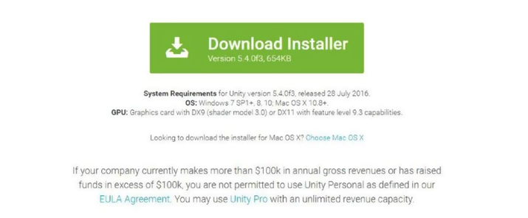

Figure 2

The site automatically offers the version that matches the platform you are currently on, but also provides a link to other operating system versions.

Performing the Installation

Because Unity regularly makes changes that can affect your projects, you may wish to use the 5.4 version even if the current version is newer. If you prefer, you can install multiple versions of Unity on the same machine, provided you name the folders accordingly (for example, Unity 5.4, Unity 5.6). Since Unity 5, you have the option to run more than one instance of Unity at the same time. Because changes in the Project view directly affect the project on your hard drive, it is not advisable to open two instances of the same project. If you choose to have multiple versions of Unity, you will be required to start Unity from the desired version rather than from the desktop icon or the project itself, as the previously run version will open by default. When you install Unity, you will be given a choice of components to install. Common choices are the Unity engine, Documentation (if you work offline on a regular basis), Standard Assets, Example Project, Microsoft Visual Studio Community 2015, Android Build Support, iOS Build Support, Windows Store .NET Scripting Backend, and Windows Store IL2CPP Scripting Backend (Figure 3). Links are provided in the Unity Build window if you decide to add more of the options at a later date.TipIf you are installing Unity to a machine that does not have Internet access, you can usually find the separate component downloads by following the links for the Unity beta releases. Be aware that Visual Studio Tools for Unity requires Internet access to install and use.

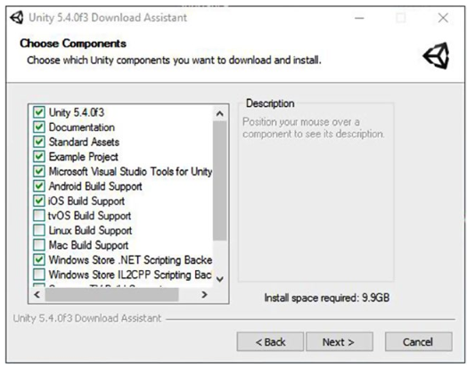

Figure 3

Install Unity, following the prompts, including the previously suggested components.

On a Windows machine, Unity will be installed in the Program Files folder. The sample project (should you opt to install it) will be installed in Documents ➤ Public Documents ➤Unity Projects. On a Mac, you will find Unity in Users ➤ Shared ➤ Unity. If you do not install the sample project and sample assets, they can be downloaded from the Unity Asset Store at a later date or through the installer.

At this point, you should see the Unity icon on your desktop

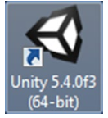

Click the icon to open Unity.

If you have not yet created an account, you will be given the opportunity to do so now, or you can choose to work offline. Next you will see the Unity start screen, where you can select a previously opened project, browse for a new project, or create and set up a new project (Figure 4)

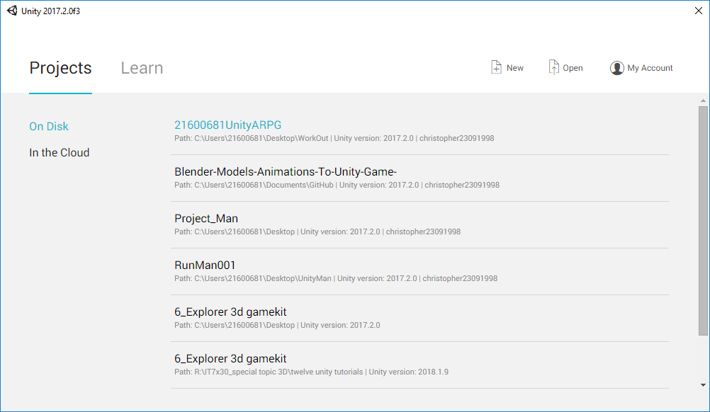

Figure 4

This screen shows information including the location and version of previously opened projects. Unity makes very little attempt at backward compatibility as it strives to improve frame rate and feature sets, so don’t be surprised if an older project does not work in a newer version. Also be aware that opening an older version will cause a project to be updated to run on the current version (as much as possible). When the update is completed, you will not be able to open it in earlier versions, so it is advisable to save a backup copy of the project folder prior to updating. Fortunately, you will be warned first and will have the opportunity to decline the update.

From the start screen, you can watch an overview video by clicking Getting Started. This overview is brief but will point you toward several of the Unity learning resources. Feel free to take a few minutes to watch the video. It is installed with Unity and does not require an Internet connection. If you do not have a Unity account, you will see a Sign In button instead of My Account in the top-right corner.

Let’s begin by examining the editor with an almost empty new project loaded: 1 On the start screen, select the New button at the upper right to begin a new project (Figure 5).

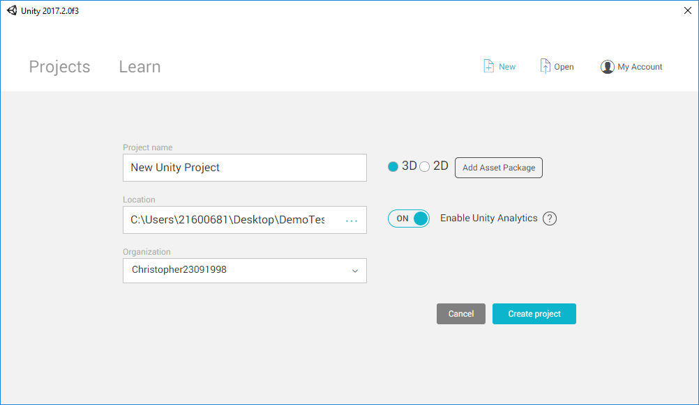

Figure 5

Besides setting the name and location of the project, you are also given the option to preload assets relevant to 3D or 2D scenes. You won’t be preloading any assets this time, but they can be imported into your scenes at any time through the editor. Best practice is to avoid loading unnecessary assets to keep your project clean and easy to manage.

2 Set the Project Name and Location manually using the Browse icon (…), or accept the default name and location.

3 With the project name and location specified, click the Create Project button.

The new project and new scene, Untitled, opens in the Unity editor (Figure 6).

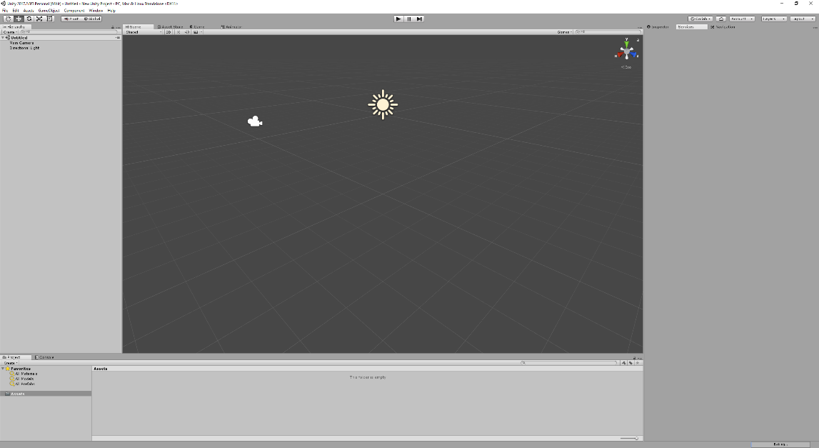

Figure 6

Exploring the General Layout

With the project loaded, you should see Unity sporting its default layout. If you are using the Personal edition, the UI should appear in light gray, as in Figure 6. If you have purchased or are evaluating Unity Plus or Pro, the background will reflect the dark theme (Figure 7). If you have Plus or Pro and prefer the lighter version, you can change the Editor Skin in the General section of Unity Preferences (Figure 8).

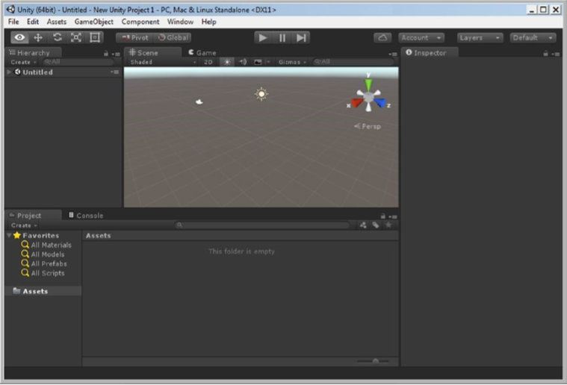

Figure 7

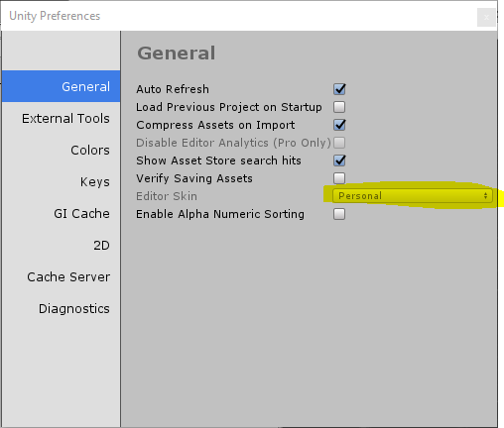

Figure 8

Unity’s UI consists of four main views and several important features. The Scene view, Game view, Hierarchy view, and Inspector view (typically referred to as the Inspector) are generally accessible in any of the layout options, as are the playback controls, coordinate system options, and object/viewport navigation buttons (Figure 9). If the term views seems a bit odd, it helps to know that depending on which view is active, your input (or the events it triggers) will generate different results. The first click in a different view sets the focus to it.

**Scene View**

**Inspector**

**Project View**

**Hierarchy View**

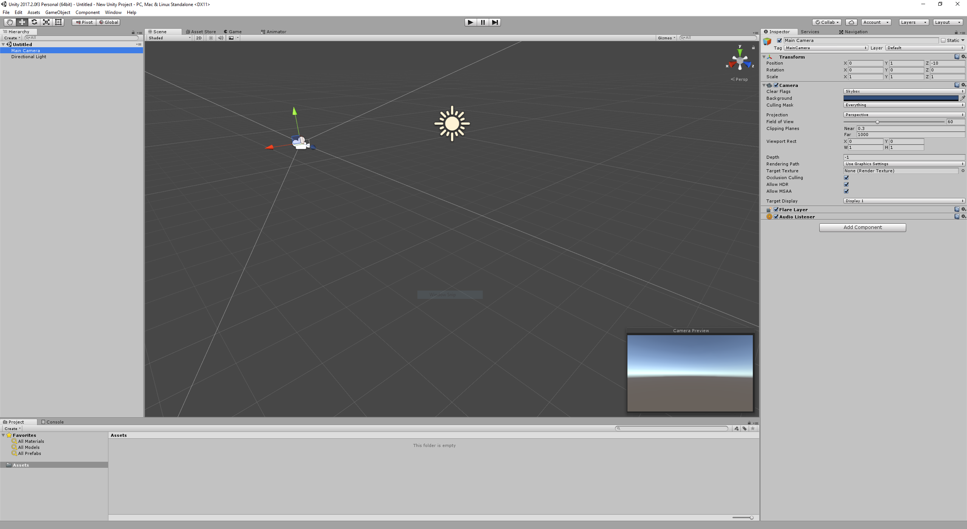

Figure 9

With the default layout, the main feature is the Scene view. This is where you will be able to arrange your 3D assets for each scene, or level, in your project.

In the tab next to the Scene view, you will find the Game view. In the default layout, when you click the Play button, the Game tab is automatically opened. In the Game view, you will interact with your scene at runtime to test your game play.

To the left of the Scene/Game viewports, you will find the Hierarchy view. Here you will find the objects that are currently in the loaded scene, or level.

Below the Scene/Game view is the Project view. This contains the resources or assets available to the current project. This folder corresponds directly to the project’s Assets folder on your operating system. Deleting files from the Project view will send them to the trash on your computer. If you author from an external hard drive, you should be able to locate the deleted files in the drive’s own trash folder. The main point here is that there is no “undo” for these deleted files in the Unity editor.

To the far right, you will find the Inspector. This is where you can access the parameters, options, and other particulars of selected assets, from the Hierarchy or Project views, as well as general project-related settings.

At the top left, the navigation controls allow you to move and arrange objects in your scene and reorient the Scene view itself for easier access to the various objects.

To the right of the navigation tool controls are the coordinate system options. Here you can specify Global or Local coordinates as well as using the object’s designated Pivot Point or the Center of its bounding box as the rotation point.

In the top center, you will find the playback buttons. The Play arrow puts you in Play mode, where you can test your game’s functionality and presentation in a Windows or Mac environment. The background color of the UI will also change, alerting you to the fact that you are in Play mode. Many types of changes during runtime will be lost once you return to Edit mode. The Play button becomes a Stop button when you are in Play mode. You also have the option to Pause the game, using the middle button, or to step through one frame at a time, using the right button.

Along the top right, you will see a button and three drop-down menus. The cloud icon is for Services, enabling Unity to provide a “suite of integrated services for creating games, increasing productivity, and managing your audience.” The Account drop-down menu provides quick access to your Unity account and lets you sign in or out. The Layers dropdown menu allows you to set various layers, such as the UI elements, to be active or inactive during Play mode, or to define new layers. The Layout drop-down menu provides a quick way to switch between several popular layout configurations.

ETC… (there is a lot more but going to take too much time)

# Scoping

# Testing

# Industry roles

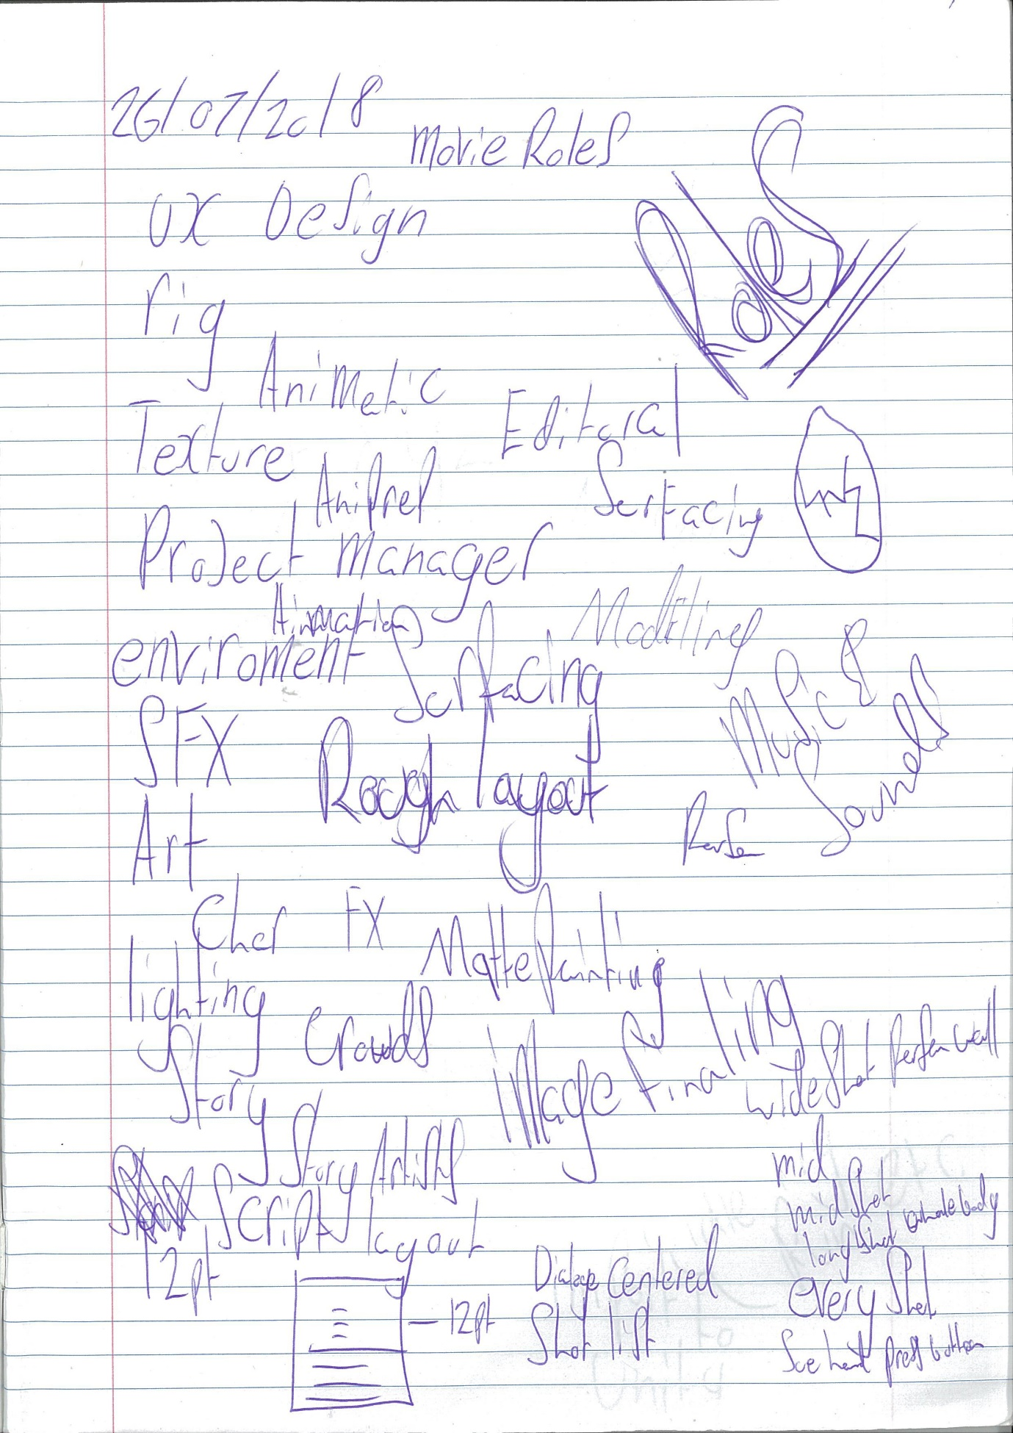

# Principles of storyboarding

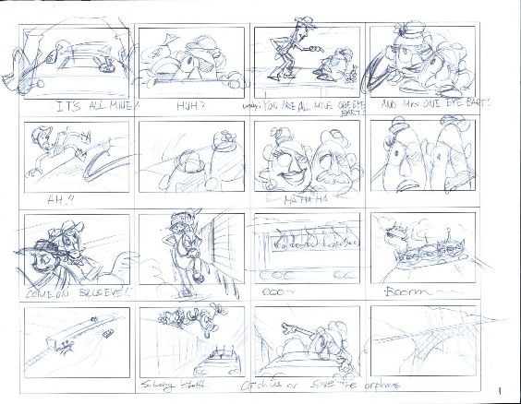

Storyboarding and Design Tips

Use the following tips to help you design and develop e-learning prototypes and storyboards.

Use clear and logical navigation.

* Apply the following principles of screen layout to ensure optimal functionality:
* Place screen objects together in a logical order. For example, in the header area, place the course title, module or lesson title, page or topic title and page numbers on the screen so that the information becomes more specific as the learner reads through the items.
* Use page identifiers such as lesson title, topic title and page numbers so learners know where they are in a course at all times.
* Place buttons where the learner’s eye can easily find them and in a place that provides the most real estate for actual course material.
* Give buttons clear symbols or labels to make them easily identifiable.
* Group buttons together based on their function and frequency of use. Place the Quit or Exit button away from the main navigational buttons such as Menu, Back, Replay and Next.

Design screen information for learner control, usability and readability.

Successful e-learning is interactive and easy to use; it also allows learners to be in charge of their own learning.

* Allow learners to control the gradual building of information on a particular screen.
* Enable learners to see the entire screen without the need to use scrollbars.
* Be aware of your target audience and their abilities. Audience members could be uncomfortable with technology or have impairments with sight, hearing, motor skills and/or colour-blindness. To solve these issues, keep your design and content simple, easy to use, with high contrasting on-screen text, and provide as many choices as possible with mouse vs. Keyboard navigational controls and text vs audio content controls
* Use interactivity (such as hot spots, rollovers and hyperlinks) to present information. This gives users autonomy in deciding what content to explore and in what order.
* Use progress indicators on a main menu screen for courses with multiple lessons. This enables learners to easily track their status in the course. Note: Use bookmarking features with caution. When re-entering the course, bookmarks jump learners into the middle of training content, potentially disorienting the learners and taking content out of context.

Provide an adequate number of examples.

Relevant examples of learning points, both for demonstration and practice purposes, provide real-life opportunities for learners to acquire workplace skills and expertise.

When designing examples, avoid:

* Overly-complicated examples. Instead, build the example throughout the course so the learner can digest the process.
* Excessive repetition. You risk losing the learner’s attention or focus.
* Because learners acquire knowledge at different speeds, allow them the flexibility to determine how many practice examples they need to complete. Advanced learners might “get it” after one example, but beginners might need two or more examples to practice.

Enable learners to interact with course elements.

Interactions motivate learners and enhance learning. To be effective, make the interactions relevant and appropriate to the instructional purpose.

Guidelines for using interaction:

When the learner is absorbing new material, keep interaction involving choices or decisions to a minimum.

* Use interaction so learners can "try out" the principle they are learning.
* Provide hints and help options to encourage and support exploratory, interactive, positive learning experiences.
* Don’t use an interaction just for the sake of using an interaction. Forcing learners to click or rollover content again and again is redundant and annoying. Provide an extra “nugget” of information or feedback at the end of an interaction to give the interaction purpose.
* The most important content, or any content that will be tested, should not be “hidden” in an optional interaction in case the learner does not interact with the page.
* When designing a test, provide at least one question per learning objective to ensure the student has mastered the material. Keep in mind that a very long test may overwhelm the learner. If a test has more than 10questions, consider testing intermittently throughout the training, perhaps at the end of each lesson.

Avoid split attention with screen design.

Split attention occurs when a learner has to hold something in working memory while searching for a matching component. It usually occurs when ever two or more sources of information are presented separately on a screen and the learner must mentally integrate them together to make sense out of the material. A classic example is displaying a diagram with supporting text in a different area of the screen

To avoid split attention, align supporting text with the appropriate graphics. Techniques such as pointers or marquees can be useful in leading the eye to important or supporting information. Consider localization and do not include text in the actual graphic files; instead, make them separate entities that lay over or beside the graphic.

Use multimedia appropriately.

Multimedia resources are most effective when they reflect the needs of the users and the hardware/software available to learners. Ensure that the audience has access to the appropriate technologies required by the multimedia and knowledge of the skills required to operate the course.

Before using multimedia, weigh its benefits against the context of the learning environment and the available resources:

* Insufficient bandwidth and slow downloads may turn a "bells and whistles" online course with large audio and/or video files into tiresomely slow delivery.
* Sound can enhance learning and create exciting interactions, but if the learners access the training in a workplace environment, the use of sound may disturb co-workers.

Other guidelines for using multimedia:

* Ensure that multimedia accommodates slower readers–information that disappears after a short time hinders learning.
* Keep distractions such as fast-paced or looping animations, special effects, sound effects and background audio to a minimum.
* Present the audio narration simultaneously with the graphics or animation for that page.
* Avoid redundant information. The most common type of redundancy is repeating audio narration and visual text exactly. Use effective “mixed mode” instructional formats; present graphics and minimal text combined with supporting information delivered using audio.
* When using audio narration with minimal on-screen text, provide the option for no audio and full screen text for those with hearing impairments or those who want to print the course content.

Reject linear thinking and abandon linear design.

A highly structured, top down approach to instructional design rarely addresses the needs and preferences of learners. While it is perfectly acceptable to suggest a path through a course, it is usually not acceptable to require a predetermined path or demand the same through disabled choices and buttons. There are rare exceptions to this rule, such as when the content or external circumstances (such as federal regulations) require it.

* Don’t force learners to interact with a screen or listen to the entire audio narration for a page, before allowing them to navigate to the next screen. Adults need to learn at their own pace or skip ahead if they already know the material. Forcing control on learners causes problems if using the course for future reference material.
* Allow learners to review course material and retake the final test as many times as they like. Provide a list of areas/lessons for review if any test questions are missed

ETC… (there is a lot more)

# Using reference material

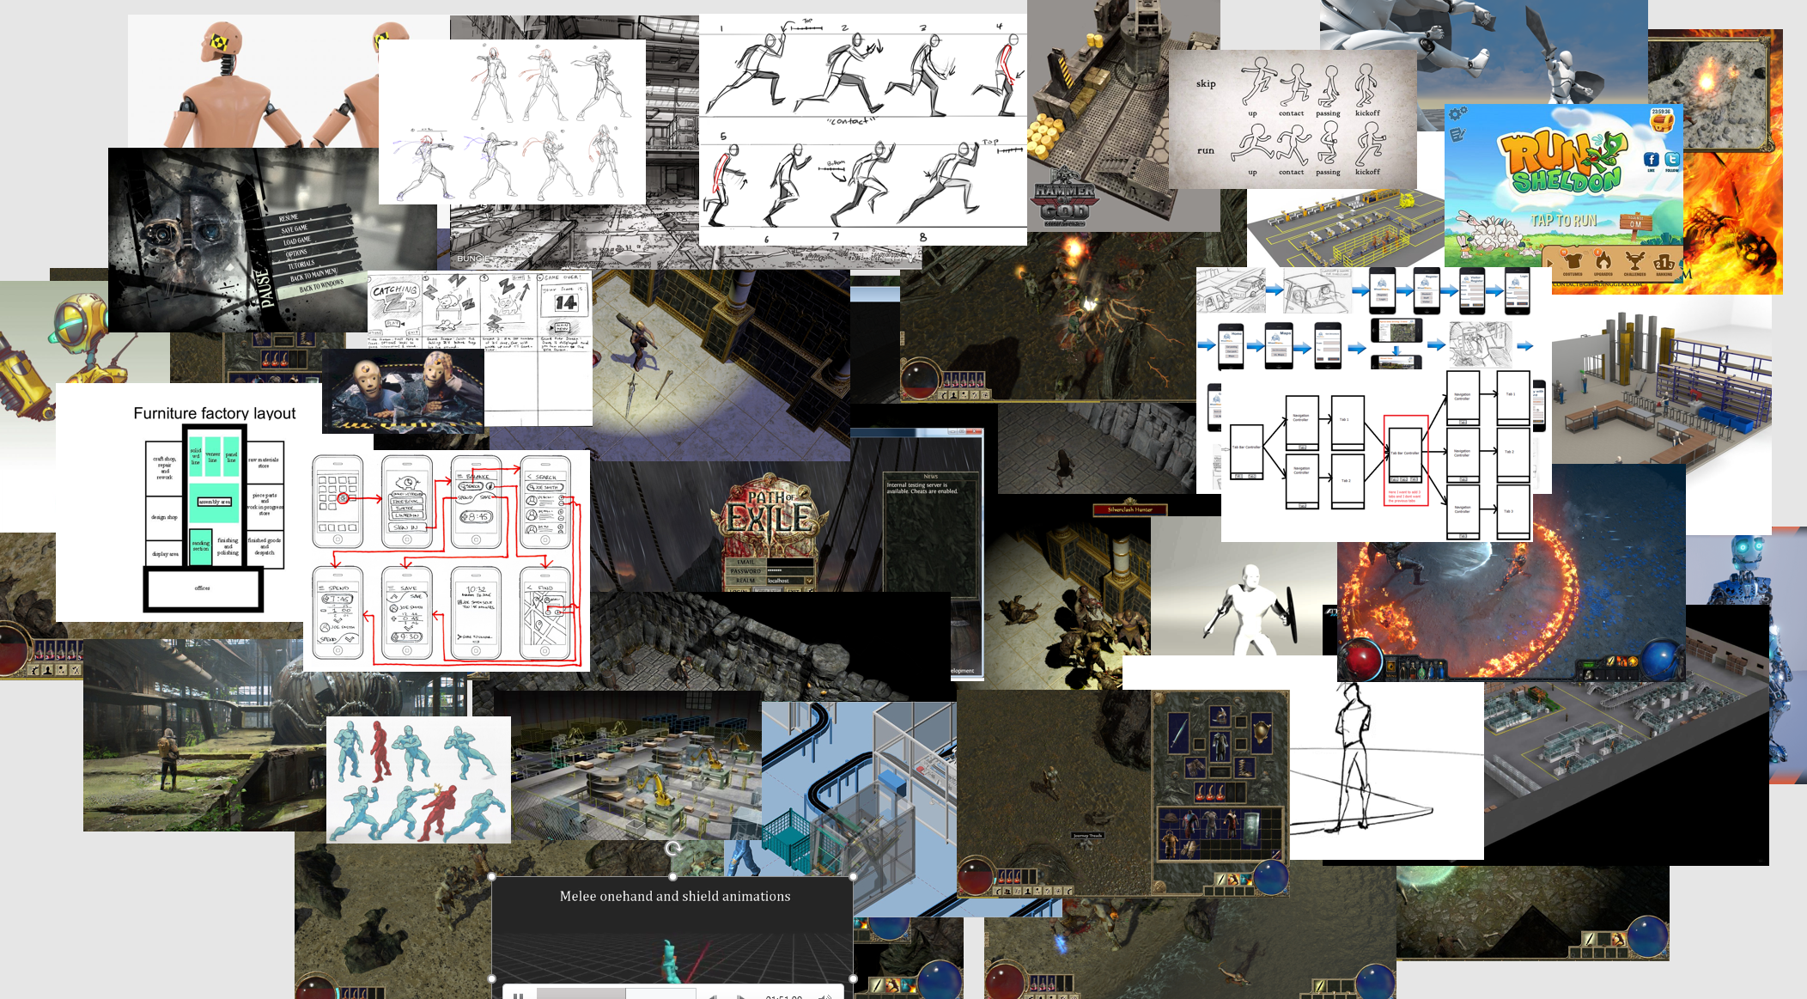

# Character design process

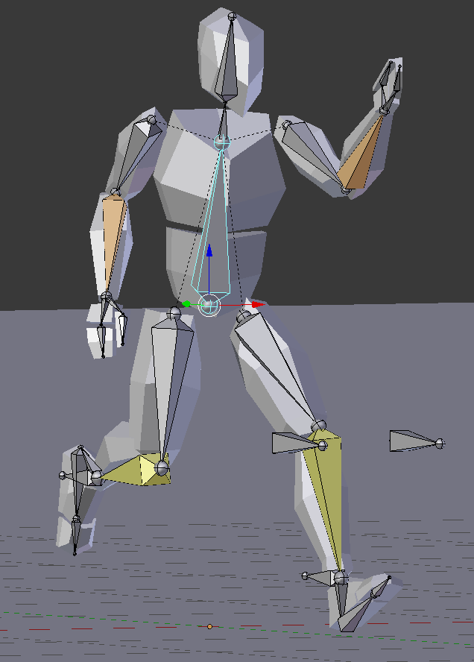 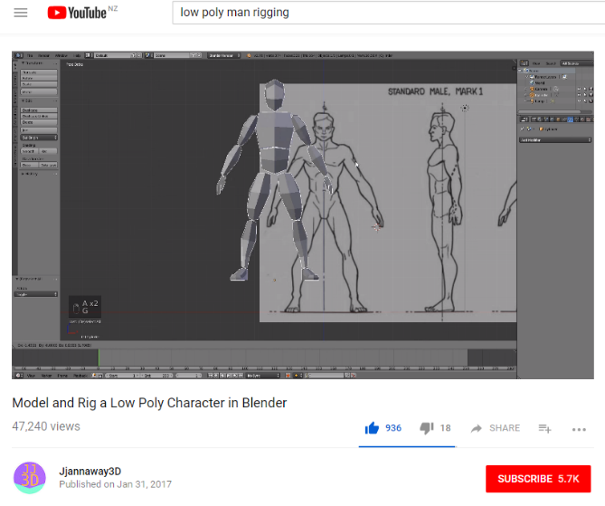 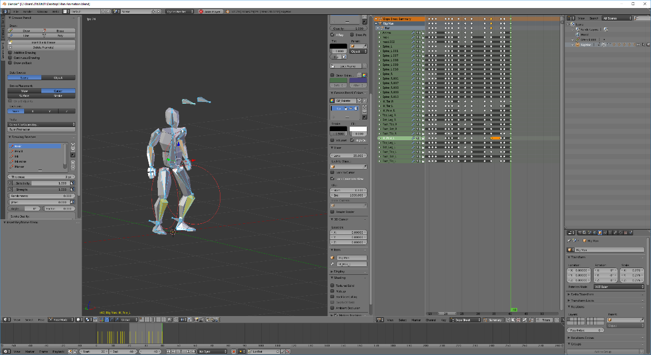

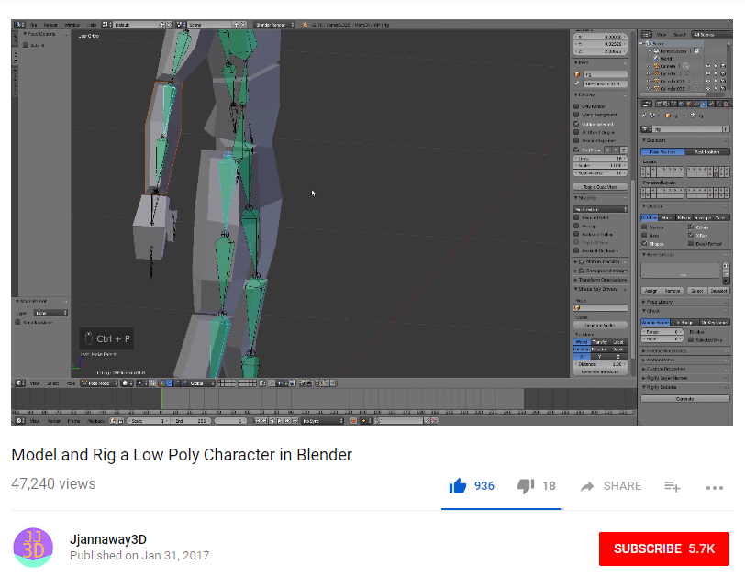

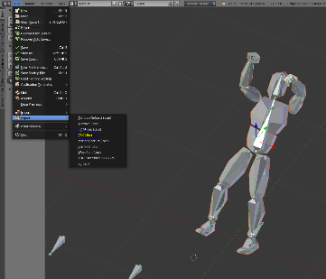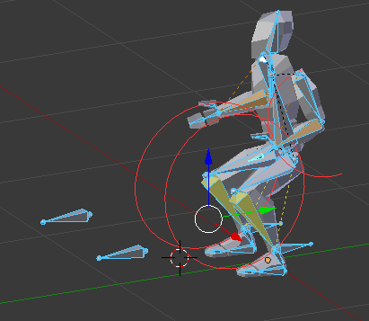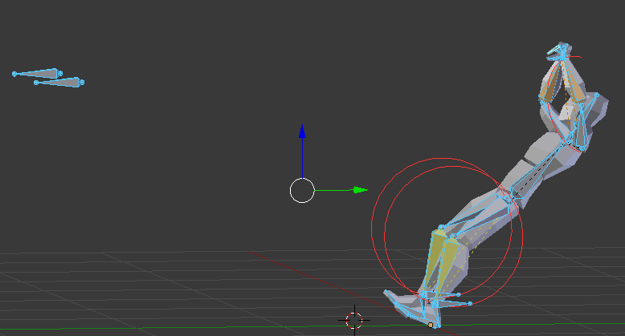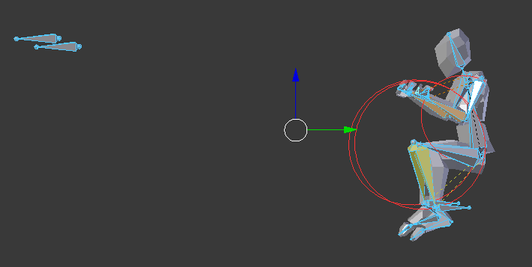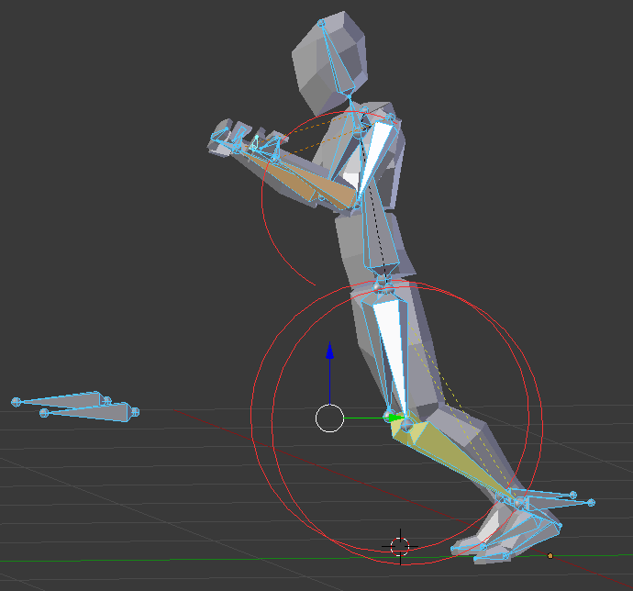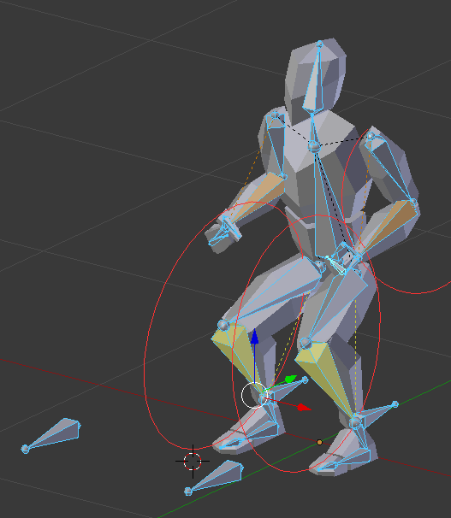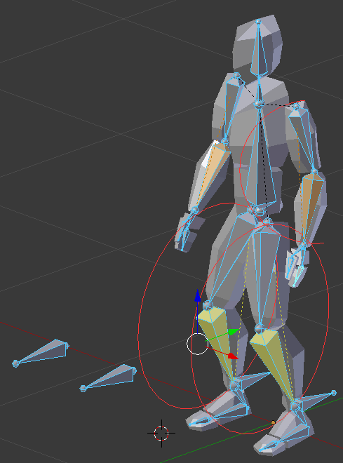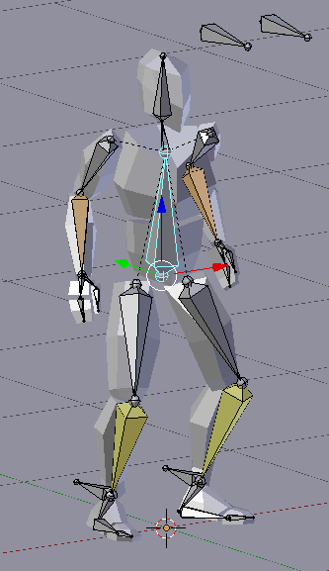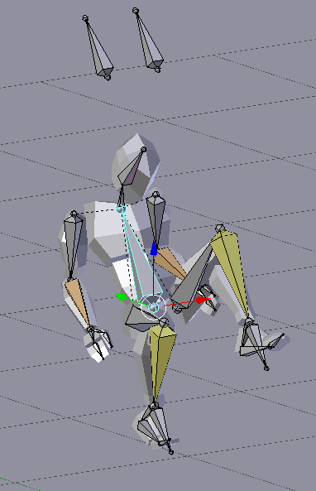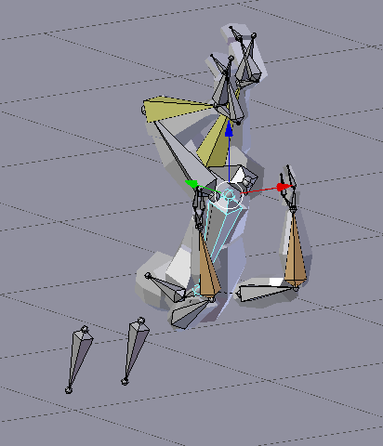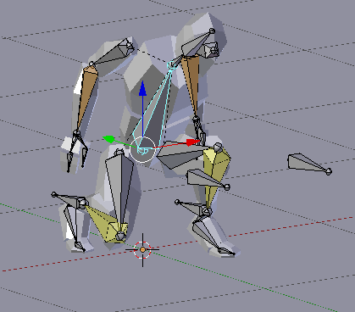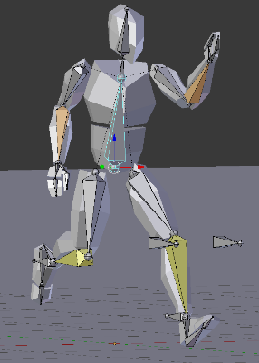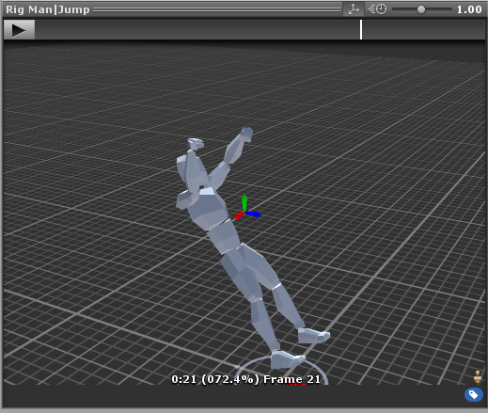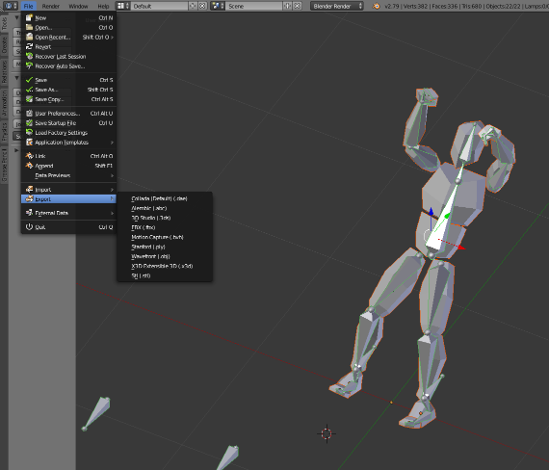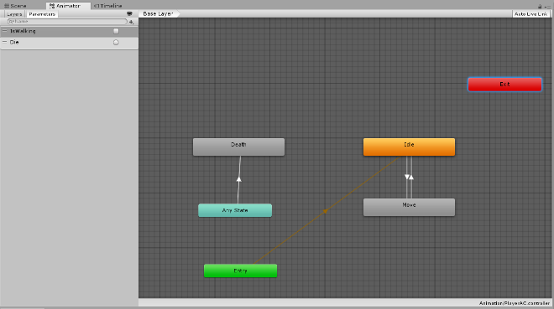

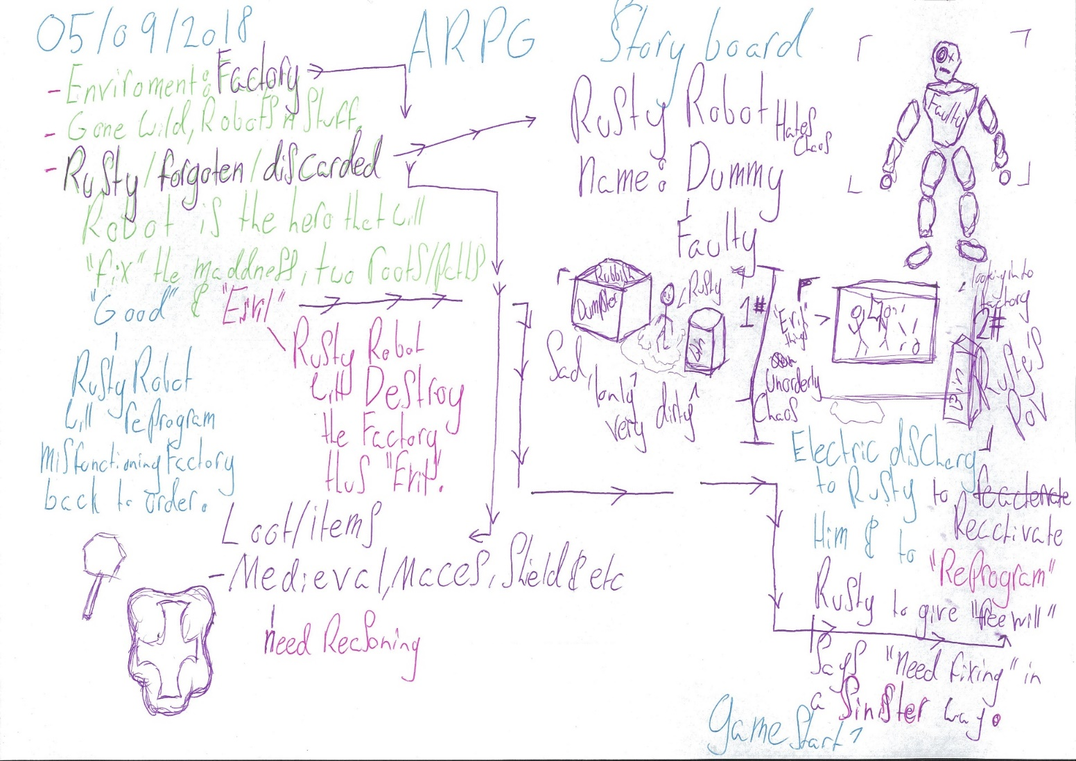

# Game Docs

Why You Need a GDD

Good Documentation is a Must

Many game designers abstain from cultivating design documents and organizing ideas. I can't imagine how these developers get through those times that they are hampered by malfunctioning code, placeholder art, and clashing mechanics, all while trying to remember why it was that they first subjected yourself to making a game in the first place. (Alex sayenko, 2015)

Having a well thought out game design document can act as your crutch in these times. It will let you see the awesome ideas and concepts that kept you up all night long when you first started on your game, and, perhaps more importantly, which ones need to be cut from the game to make your life easier, or reworked to make your efforts worthwhile. (Alex sayenko, 2015)

A GDD Aids Game Design and Development

A game design document acts as a nexus and hub to connect and list every aspect of a game. It consists of written descriptions, images, graphs, charts and lists of information pertinent to each segment of development, and is often organized by what features will be in the game, and clearly lays out how they will all fit together. (Alex sayenko, 2015)

Creating a GDD will aid your team's designer in understanding what the essence of the game is and the planned scope of its overarching world and gameplay. Plus, having all the game elements in one well-organized document will help the designer easily convey their vision to the rest of the team, while also helping to pinpoint weaknesses or missing components that the game may require. (Alex sayenko, 2015)

The GDD should serve as your master checklist. It will be the document you toss up in the air in celebration upon completing all its sections and finishing your game. (Alex sayenko, 2015)

A GDD Helps in Other Areas, Too

Since a GDD is full of descriptions, it is an ideal resource for all PR and marketing fronts, with concepts that convey the game's aesthetic and appeal already written up and ready to copy and paste. (Alex sayenko, 2015)

Prospective employees' skills can be quickly assessed as qualified or not by looking at their credentials alongside their positions' corresponding sections in the document. (Alex sayenko, 2015)

If fundraising is in the cards for your team, it will be crucial to have a well put together GDD for investors to look over and determine the risks of your development, as well as your ability to deliver on your promises. (Alex sayenko, 2015)

A GDD Keeps Everyone on the Same Page

Creating and adhering to a game design document is like planting a seed and watching it grow into a tree over the course of development. You have your initial preparation, cultivation, and ultimately the gruesome and backbreaking toil of the harvest. (Alex sayenko, 2015)

A common mistake is not handing all your team members the proper gardening tools to make your game a reality. The GDD will help make sure everyone is working together, so that you don't find your programmer and artist cutting off the branch they are standing on. (Alex sayenko, 2015)

Common Mistakes

Trying to Describe Everything at Once

It is not necessary to list every feature and mechanic in detail in the first draft. This is impossible when working on a complex game with a small team. Outlining the major nodes of gameplay and core elements will help give you perspective on what needs to get done, but you should expect to fill them in one by one, over time. (Alex sayenko, 2015)

Not Setting Deadlines

Setting game goals with deadlines may seem off-putting to some developers. Deadlines are a part of the boring 9-to-5 lifestyle, so many people have a natural aversion to them. (Alex sayenko, 2015)

However, setting deadlines is how you ensure that your game will get made and not sit forever unfinished in a folder on your desktop. These types of goals are milestones on the road to progress, and passing them one by one is a clear indication that you are doing something right. Each is a cause for celebration. (Alex sayenko, 2015)

Deadlines are a basic component of scheduling that helps you monitor the performance of your team and yourself. It aids in decision making that is rooted in reality, and eventually builds up a momentum and ethic that is healthy for the team as a whole and the individuals within it. (Alex sayenko, 2015)

Assuming Everyone Knows What to Add

There is room in the GDD for basic descriptions that cover gameplay, storylines, and major coding tasks. As development progresses, you add more details to these sections. While creating and testing the game, you should add or update specific technical details every time a feature is implemented or changed. This way, you'll never have a build with elements that you can't trace back to the GDD, creating missing links of ideas, code or art. It can also be helpful to add information about the difficulty of implementing certain tasks, and whether they have been fully integrated into the game or may require further revision. (Alex sayenko, 2015)

Throughout this process, your initial concepts should be trickling down into ever more detailed descriptions of each facet your features contain. This helps make concrete milestones that are easy to navigate and backtrack to see where they originated and where they need to go. (Alex sayenko, 2015)

As the GDD continues to grow and become more finalized it is still important to keep it up to date. This eliminates situations where team members do something without being able to justify why they spent time doing them, which is crucial come crunch time. (Alex sayenko, 2015)

Printing the GDD

Personally, I have an unexplained primal fear of drowning in a heap of printed documentation. This would become a real nightmare if I had to keep all old versions of our GDD for every team member. (Alex sayenko, 2015)

Why should we torture ourselves like this in the age of digital technology? There are plenty of free online services like Google Docs or Trello that let you save all changes and see all your team's comments in real time. (Alex sayenko, 2015)

How to Write an Effective GDD

Write It in Stages

When starting the GDD, it is normal to get wrapped up in concepts. Backgrounds, introductions, and key descriptions help to flesh out the game and give it shape. As you begin to test and implement features, these concepts should become more refined, specified and detailed. Maintaining proper organization will become more and more critical as your GDD gains weight and density. (Alex sayenko, 2015)

Start in the concept phase, where you brainstorm your ideas and get them all down on paper. This should be exciting! It will also serve as a roadmap so you don't lose track of your goals and vision along the way. When the appeal of certain game elements lose their lustre or lead you into a ditch, it may be time to rework your initial concept to make sure you reach a satisfying finish line. (Alex sayenko, 2015)

Towards the middle of development, once you have a gung-ho team on board, discussions and game builds will help sculpt and organize the document into an easy to use and hefty guide for everyone. There's still room for experimenting with new concepts and ideas at this point, but they should be kept in check with some of your initial documentation. (Alex sayenko, 2015)

The home stretch of development is where your game design document will save you hours of frustration and heartache. As you close in on release your GDD should slowly start turning into a stone tablet, with features and mechanics set in more permanent game builds all held together by art that was surely crafted over multiple iterations to match the document's specifications. The document should help keep all the team's wheels on the ground, with a good line of sight on realistic expectations on delivering the game. (Alex sayenko, 2015)

It is not necessary to have an absolutely complete GDD before starting development. But the GDD must be complete for the next 10 days or two weeks beyond your team's current work—and the relevant parts of the document must be as detailed as possible. (Alex sayenko, 2015)

Allow Changes During Your Game's Development

Parts of the GDD will have to be changed and modified throughout the entire development process, sometimes even in the final days before release. It can start to resemble a disaster zone if the content is not trimmed properly. If you are afraid of deleting text that is outdated, cut and paste it into an addendum or separate document. This will leave the main body of the GDD relevant to the current state of development, without all the distractions of previous iterations. (Alex sayenko, 2015)

Don't ever stop team members submitting new ideas. Idea creation is one of the most rewarding parts of development, and should be encouraged at all times. Your team members should head into development knowing that many of these concepts will be cut and never make it into the game, but this shouldn't stop them from dreaming! No one knows what ideas will produce the best results at first, so generating new and innovative ideas should be a staple of your discussions and celebrated accordingly. (Alex sayenko, 2015)

Put Just One Person in Control of It

Supervision of the GDD must be performed only by one team member. They will identify the key ideas that must be focused on, and cut the less important ideas. (Alex sayenko, 2015)

Encouraging active feedback is important, then, because other team members do not have the chance to add their ideas to the document directly. (Alex sayenko, 2015)

Most development issues are comprised of a hard outer shell of miscommunication and a soft interior of not knowing how to compensate and correct them. These barriers can be eliminated with vigilant maintenance of the GDD and clear, concise documentation, and this can best be achieved if one person takes on that responsibility. (Alex sayenko, 2015)

Focus on Readability

Be consistent with font styles and using uniform headers and indentations, punctuation, and formatting. Creating a legend or key to explain what specific colored highlights mean can go a long way toward reducing confusion and cutting down on the time it takes to convey the stages of different features' implementation. (Alex sayenko, 2015)

Keep the Language Clear

The simpler and clearer you keep the language in the GDD, the better your team will understand it. (Alex sayenko, 2015)

It's important to keep the writing clear and concise, and your team should actively give you feedback about the presentation and clarity of the GDD. A back-and-forth dynamic will result in a more cohesive development experience, with overarching benefits including a defined art style, fewer communication errors, and less stressful documentation and office work. (Alex sayenko, 2015)

But most importantly, the GDD should be a reflection of your team culture, created in whatever format you find works best and is most appealing to you and those you work with. (Alex sayenko, 2015)

Use Visual Aids

No one should ever be able to say that they haven't understood something, or done something correctly, due to a lack of reference material in the GDD. (Alex sayenko, 2015)

Visual materials and references play a key role in the process of conveying ideas. Some difficult concepts can be explained in less time with visual aids like graphs and concept art. This will help ensure every team member understands the information that is conveyed to them, which in return will help them to complete development tasks faster. (Alex sayenko, 2015)

Put Some Passion Into It

You should not restrict yourself to dry text. (If you do, you'll be waiting a long time for everyone to get engaged and understand the main ideas!) Try to describe the players' emotions and the experiences that the game might cultivate. (Alex sayenko, 2015)

Keeping a GDD may sound technical, but you shouldn't be afraid to tear your heart out and throw it at the document. Let your emotion and passion bleed into it. Imagine how you want to make the player feel, and write those aspirations down alongside the descriptions of your features. This helps to cultivate a collective consciousness in your team about what your game is trying to convey to the player—and, let's face it, feelings should have enthusiasm behind them if you want them to be understood by anyone else. (Alex sayenko, 2015)

Use It to Keep People on Track

Set the priorities of tasks and features, document their deadlines, and control their execution. You can't develop absolutely all the ideas which your team and your mind will propose, so (after you've cut some of them), you need to set their priorities and at least approximate a schedule for their implementation. (Alex sayenko, 2015)

A well-groomed GDD makes for an excellent, prioritized list of tasks that need to be completed by your team. Not all the features in a GDD will make it into the final game. With this in mind, you must decide which features take precedence over others, and you should schedule them for implementation and testing before those others. (Alex sayenko, 2015)

Think hard about what is critical for your game, and what is possible given your team's skill level, and use that information to guide your production. (Alex sayenko, 2015)

A solid GDD can also help ease new team members into the project, and get them just as excited about it as you are. (Alex sayenko, 2015)

Since a fully outlined GDD may result in what seems like an excessively daunting game to make, it is good to remember that more than one person will be fleshing out its specifics. Assigning your team members tasks in the GDD will help it to become more robust while keeping everyone on the same page. Anyone can jump in to the document and see what has been completed, what tasks lay before them and the rest of the team, and why they are working on their current task. (Alex sayenko, 2015)

Continue Having Design Discussions

Writing something in a shared GDD shouldn't minimize or eliminate discussion with the team, it should serve to increase team discussion and improve your communication dynamics. It's important that everyone clearly understands how you (and the other team members) imagine each feature of the game. (Alex sayenko, 2015)

Cutting ideas can be difficult and unnerving, but it is a process innate to creating games. Making sure that open, free discussion is a part of development will help ease the inherent tensions here, without dissuading members from being creative. (Alex sayenko, 2015)

Play the Game In Your Mind

I found many good ideas virtually playing the game in my mind, both before and during the game's creation. Of course, this doesn't give any guarantee that those ideas will take roots in the game during development and testing but, especially in the early stages, it's a good method of brainstorming. (Alex sayenko, 2015)

Set Realistic Goals

While it is good to foster an air of excitement within a team, it is equally important to keep your game goals embedded in reality. Mechanics and complex enemy and level behaviors always look great on paper, but reality has a way of corroding the grandeur of certain game elements, and this should be expected.

Consequences of updates and changes are almost impossible to foresee ahead of time in some situations, so just remember it is your job to try and limit the amount of remodelling that needs to be done when changes arise. If you make it common practice to play through new ideas in your mind before putting them down on paper, you stand a greater chance of keeping development goals rooted in realistic expectations. (Alex sayenko, 2015)

Make Use of Free Online Tools

Our team is multinational. We live around the world, in different time-zones, and this makes it impossible to use print versions of documents for everyone, and difficult to have real-time conversations. Using tools such as Skype (for conversations), Google Drive (for sharing files), Google Docs (for collaborating on documents, and sharing the GDD), and FlockDraw (for digital drawings) can really help with explanations and discussions. (Alex sayenko, 2015)

Conclusion

If you find yourself on the fence about whether maintaining a GDD is necessary for your game's production, you should take a good, hard look at how you envision development. There are almost certainly times where real life and full time jobs will get in the way of game making, or your implementation of features and mechanics simply does not work out.

On the stormy seas of game development, a healthy GDD can serve as a sturdy and solid vessel, and even a lifeboat at times. It is a detailed journal of your struggles and triumphs, a collection of thoughts and ideas for you to fall back on during hard times. You might find that improving the quality of the GDD trickles down into the rest of development as well, raising the bar across the board for your team. It should serve as a sturdy hub to facilitate team discussion and generate new, even greater ideas. At the same time, it can keep these concepts in realistic check.

The benefits of this type of efficiency may seem small when looked at individually, but over the long course of development, it builds up a wonderful kind of momentum. Ultimately, this type of document should propel, compel, and inspire you and your team to finish what you started. It should show you that your game has a plan that can be realized.

And after you have finished your game, your GDD will stand as a testament to all of your hard work and efforts, the behind-the-scenes of an elaborate experience to be enjoyed by all. (Alex sayenko, 2015)

# Planning

# Media and animation theory

# Some advances modelling tools

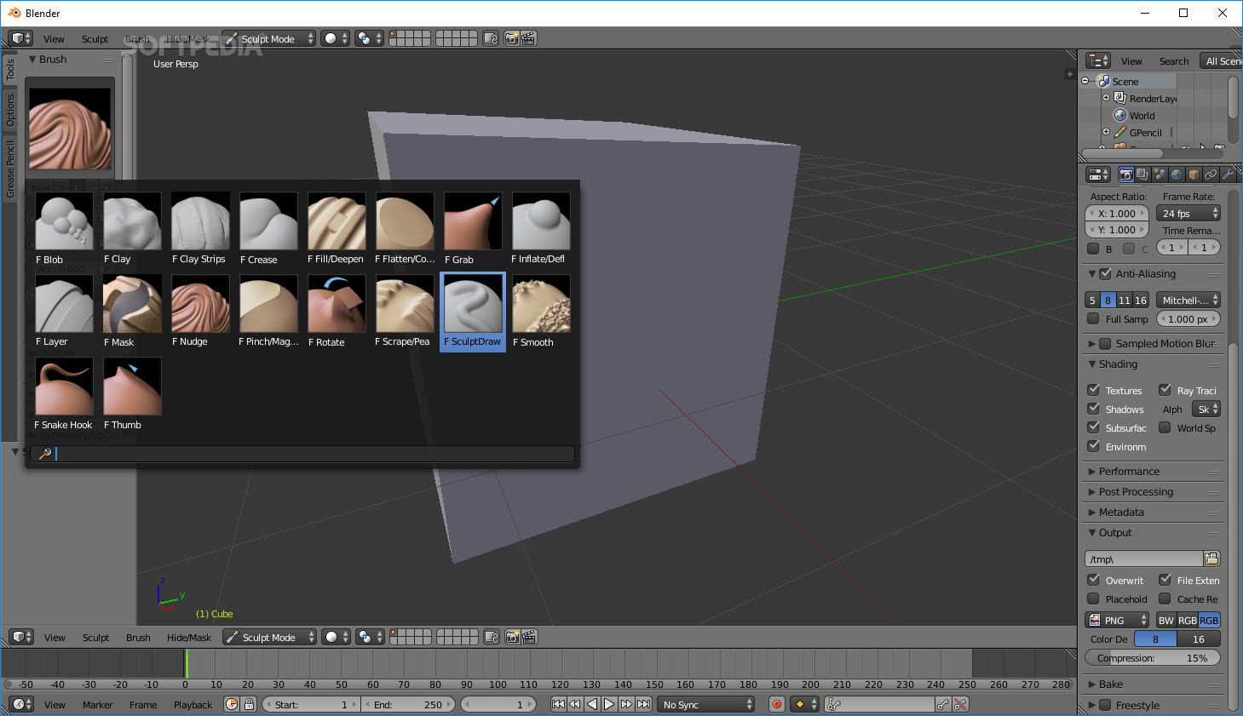

# References

Alex sayenko, A.S. (2015, 24 Apr). Envatotuts+. [Weblog]. Retrieved 24 October 2018, from https://gamedevelopment.tutsplus.com/articles/how-and-why-to-write-a-great-game-design-document--cms-23545